DAY 18: Command and Control Introduction
- What is Command and Control?
The communication infrastructure that hackers use to control infected computers or networks remotely. Hackers commonly attempt to mimic normal, expected traffic to avoid detection. There are many ways an adversary can establish command and control with various levels of stealth depending on the victim’s network structure and defenses. [1].
- Common C2 tools & framework:
- Metasploit
- Cobalt strike (very common, and so many vendor found countermeasures [2]
- Sliver
- Mythic: this is common Command and Control platform designed for red teaming and adversary simulations [3]

DAY 19: Design attack chain
In this day, I designed an attack flow diagram that indicates attack chain step-by-step:
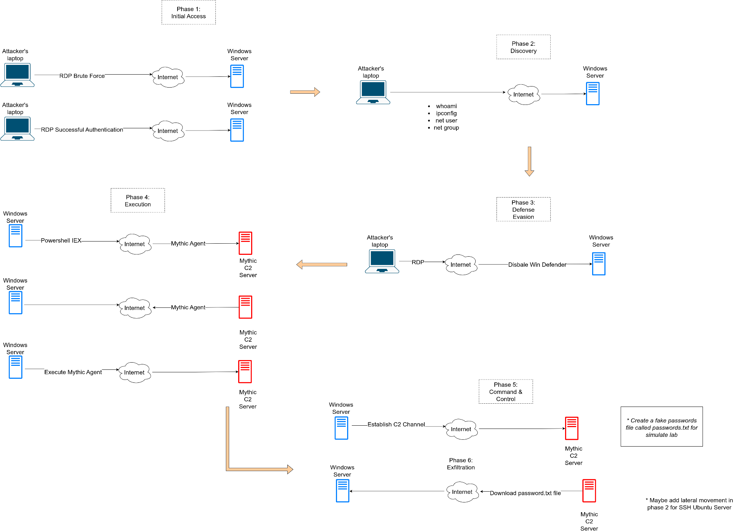
Figure 1: Attack chain flow
In the attack simulation as shown in Figure 1, It is broken down into 5 phases:
- Phase 1 - Initial Access: Attacker can implement reconnaissance using search engines as Shodan or Censys I mentioned in Day 15. Then, the adversaries will brute force to get access into my Windows Server machine. After the attacker finds the correct username and password combination, they are going to use an RDP client to connect to the Windows machine over the RDP protocol.
- Phase 2 - Discovery: The adversary will explore the network and determine hosts up or reachable, view user accounts on compromised computer, identifying current privilege to achieve high-value accounts (like domain account) or privilege escalation on the victim network.
- Phase 3 - Defense Evasion: if the attacker knows that the account they compromised has high-privilege on the machines or network, they will disable the protection mechanism as Windows defender, Windows Host Firewall,... to perform further action in the next phases.
- Phase 4 - Execution: The Attacker will use powershell to install Mythic Agent payload as Apollo that was created on Mythic GUI from C2 server, and then the adversary will run the Mythic Agent on that machine.
- Phase 5 - Command and Control: In this phase, Communication channel between Compromised Windows and C2 server will be established successfully. At this time, the attacker will send commands to the compromised windows through an encrypted channel, and the Windows machine will execute those commands and send the results back to the attacker’s Mythic Interface.
- Phase 6 - Exfiltration: The attacker will aggregate sensitive files on that Windows machine, compress it, then download it to the C2 server through an encrypted channel that is established in phase 5.
Refer to [1] entry at Appendix table

DAY 20: SETUP MYTHIC SERVER
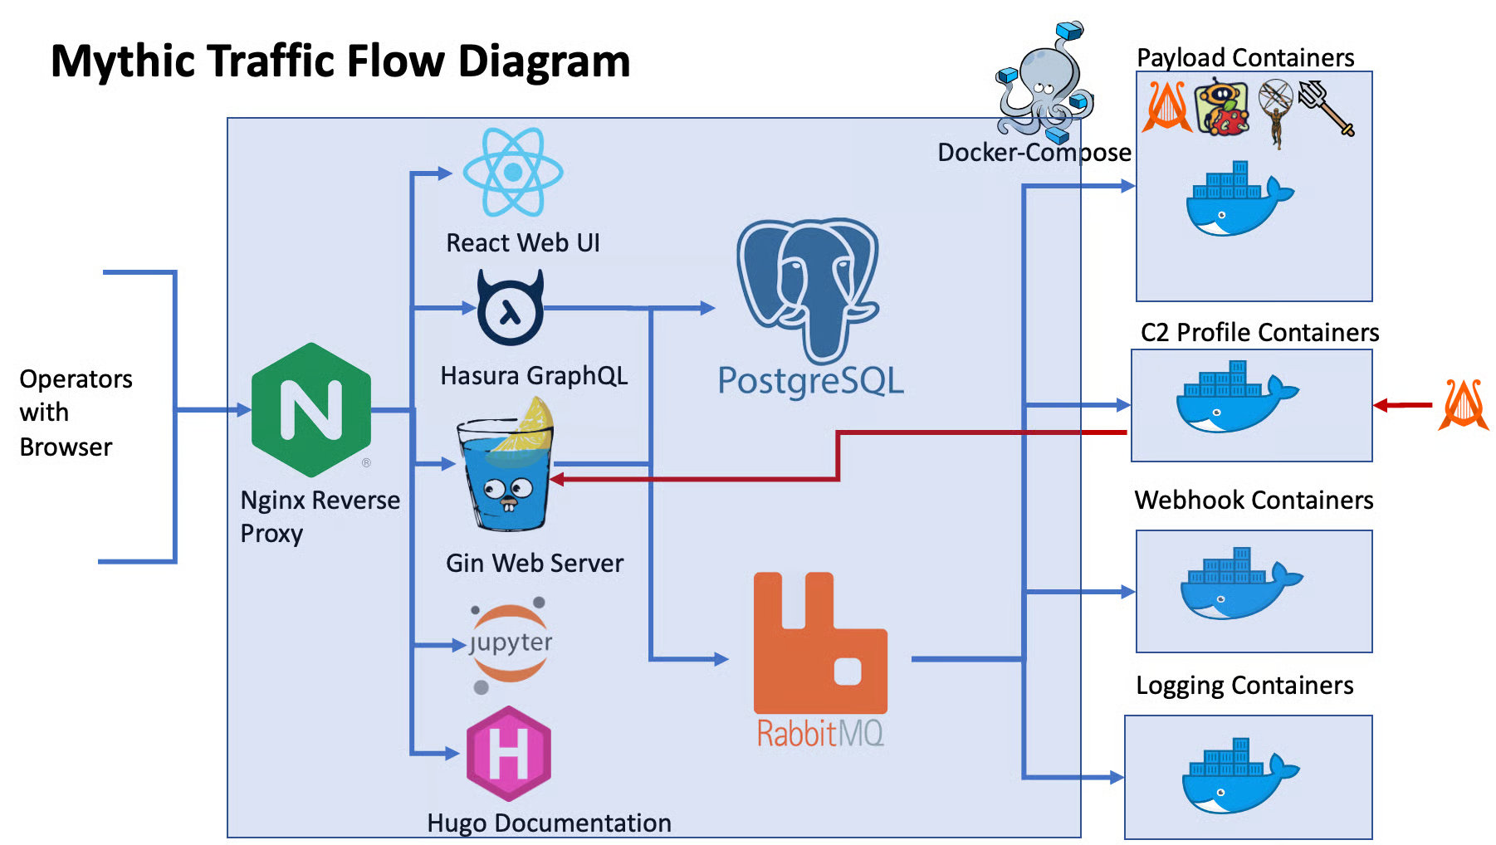

Figure 1: Mythic traffic flow diagram
I created a virtual machine on Vultr to act as an attacker’s C2 server. Now, I will clone Mythic from the official Github Repository at this link [4], then run mythic-cli script with argument “start” to bring up all default Mythic containers.
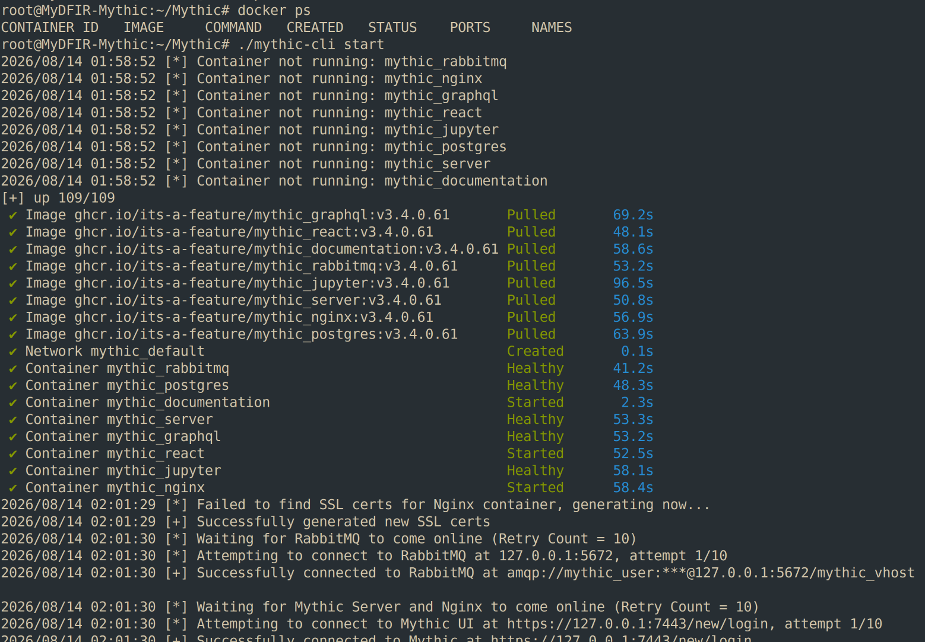
Figure 2: start Mythic containers

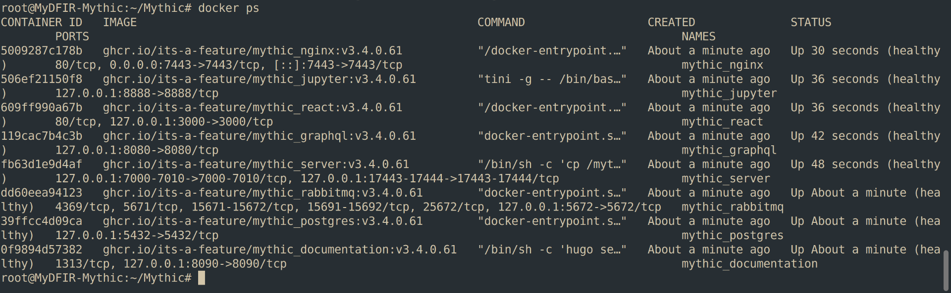
Figure 3: Active Mythic containers
As you can see, there are a lot of active containers as soon as I used the script, like mythic_nginx serve as Reverse Proxy, mythic_react provide Web UI, mythic_postgres - An instance of a postgresql database, mythic_server - An GoLang gin webserver instance,... and further information was displayed like port number, software version, command, time created, status of the container when using docker ps command.
Now, let’s access Mythic Web UI via https://<C2 server’s ip>:7443. After I enter this url in a browser, the HTTP request will be received by reverse proxy nginx listening at port 7443, then forwards it to React Web UI.
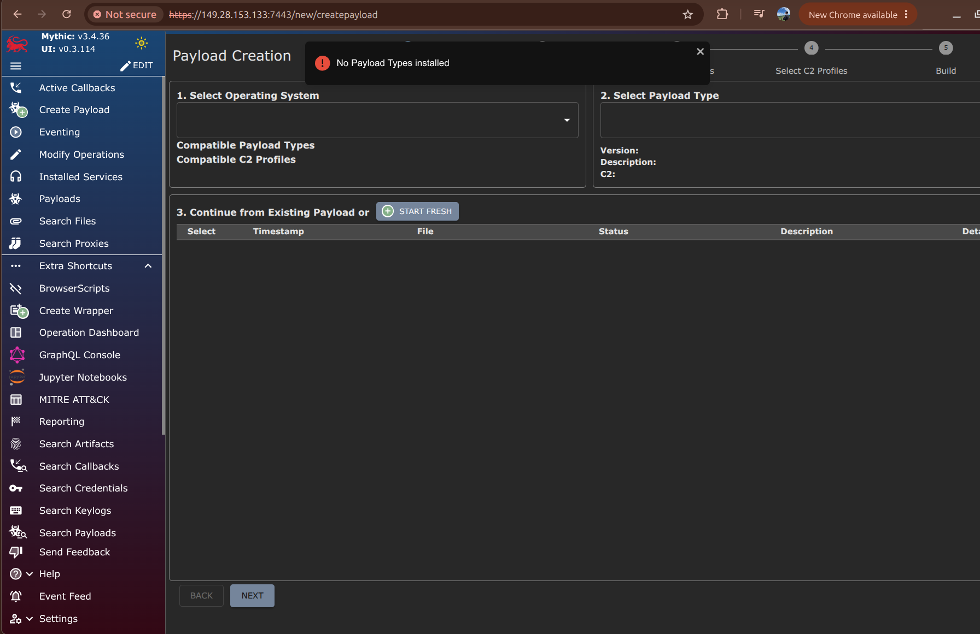
Figure 4: Mythic GUI
As shown in Figure 4, The Mythic UI looks quite simple, but it provides a lot of features for pentester/red teamer to simulate real-world C2 control traffic. We can create payloads, distribute and run them in a controlled environment, and monitor the communication between victim and C2 server as well.

REFERENCES:
[1] https://attack.mitre.org/tactics/TA0011/
[2] https://thedfirreport.com/2021/08/29/cobalt-strike-a-defenders-guide/
[3] https://mythicmeta.github.io/overview/agent_matrix.html
[4] https://github.com/its-a-feature/Mythic.git
[5] Mythic documentation: https://docs.mythic-c2.net/version-4.0/home

Appendix Table:
[1] | Attack chain design | https://app.diagrams.net/#G1mttNszED4mZTK4gl_f2HrW3IcKmKejHM#%7B%22pageId%22%3A%22tacWSezWs4LKaOrmrsYE%22%7D

